Unit 5 Day 6

Today, we are going to learn how to compare and contrast two animals.

To **compare** 2 animals, means to find how the 2 animals are alike.

How is a lion and elephant alike?

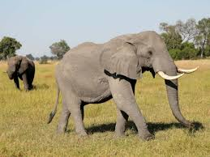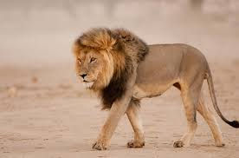 Lion Elephant

A lion and elephant both have 4 legs and a tail.

To **contrast** 2 animals, means to find how the 2 animals are different.

How is a lion and elephant different?

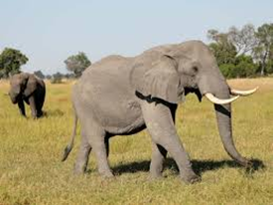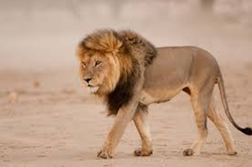 Lion Elephant

A lion has a mane and an elephant has tusks.

How are zebras and horses alike and different? Can you give 2 ways they are alike and 2 ways they are different?

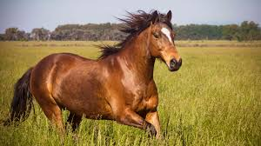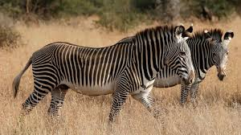 Zebra Horse

Alike – Zebras and horses both have 4 legs and a tail.

Different – Zebras have black and white stripes. Horses are usually a solid color. Horses have longer legs than zebras which means horses are taller than zebras.

How are cows and pigs alike and different?

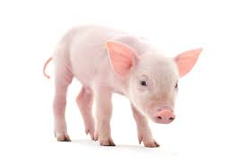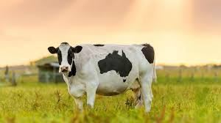 Cow Pig

Alike – Cows and pigs both have 4 legs and they both can live on a farm.

Different – Cows can have spots on them. Pigs are a solid pink color.

Activities! You are welcome to do all of these activities but please do at least three of them.

1. Have your child choose 2 animals and have them write how the 2 animals are alike and different.
2. Have your child re-read the weekly story, from last week. The document will be up on this week’s webpage.
3. Have your child write these words 5 times each (compare, contrast, alike, different). They might need a visual model, so you have to write these words out on a separate sheet of paper, and have them copy what you wrote.
4. Have your child practice these simple sight words 5 times each (before, many, going, once, live). This means to say the word, have the child say the word, and write the word.